PART - B

INTERACTIVE Q/A BOT WITH DOCUMENT UPLOAD

# **1. Introduction**

The Interactive QA Bot is a web application designed to facilitate document-based question answering. Users can upload PDF files, ask questions about the content, and receive contextually relevant answers. The system integrates several advanced technologies: Pinecone for efficient document retrieval, Cohere for natural language generation, and Streamlit for the user interface.

# **2. Uploading Files**

1. Application Launch:

Open your web browser and navigate to the URL where the Streamlit application is hosted. You will see the application's title "🧠 Interactive QA Bot with Document Upload 📄" at the top.

2. PDF Upload Interface:

Find the file uploader widget in the center of the page labeled "📂 Upload a PDF document". This widget allows you to choose a file from your local file system.

3. Selecting the File:

Click on the uploader widget. A file dialog will appear. Navigate to the location of your PDF document, select it, and click "Open". Only PDF files are supported.

4. Processing the PDF:

After selecting the file, the application starts processing the PDF. You will see a spinner icon with the message "Processing PDF... 🔄". This indicates that the file is being read and processed.

5. Text Extraction:

The application uses `PyPDF2` to extract text from each page of the PDF. The extracted text is then prepared for embedding.

6. Embedding and Indexing:

The extracted text is split into manageable chunks. Each chunk is embedded into a vector representation using the `sentence-transformers/all-MiniLM-L6-v2` model.

The embeddings are uploaded to Pinecone for efficient retrieval.

7. Completion Notification:

Once processing and indexing are complete, a success message "✅ Document processed and embeddings saved!" will be displayed, indicating that the document is ready for querying.

# **3. Asking Questions**

1. Query Input:

Locate the text input field labeled "💬 Ask a question about the document:". This field allows you to type in your question related to the uploaded document.

2. Query Submission:

Type your question into the text input field. Ensure that your question is clear and specific to get the most accurate results.

3. Information Retrieval:

After submitting your query, the application begins retrieving relevant information from the Pinecone index.

A spinner icon with the message "🔍 Retrieving information..." will appear while the application performs the retrieval process.

4. Document Retrieval Process:

The query is embedded into a vector using the same embedding model used for document text.

The embedded query is used to query Pinecone for the most relevant document chunks based on similarity.

5. Displaying Retrieved Documents:

The relevant document chunks are displayed under the section "📄 Retrieved Documents:". Each chunk is shown with its content, which helps in understanding the context used for generating the response.

# **4. Viewing the Bot's Response**

1. Generating the Answer:

Once the relevant documents are retrieved, the application uses Cohere to generate a response.

A spinner icon with the message "🧠 Generating answer..." will be displayed during the response generation process.

2. Contextual Answer Generation:

The application aggregates the text from the retrieved documents to form a context.

Cohere's model, `command-xlarge-nightly`, is used to generate a coherent and contextually accurate answer based on the provided context and user query.

3. Displaying the Answer:

The generated answer is shown under the section "💡 Generated Answer:". This provides the final response to the user's query, derived from the context of the document.

# **5. Example Interactions**

Example 1:

- Document: A PDF titled "Introduction to Artificial Intelligence" is uploaded.

- User Question: "What is Artificial Intelligence"

- Output:

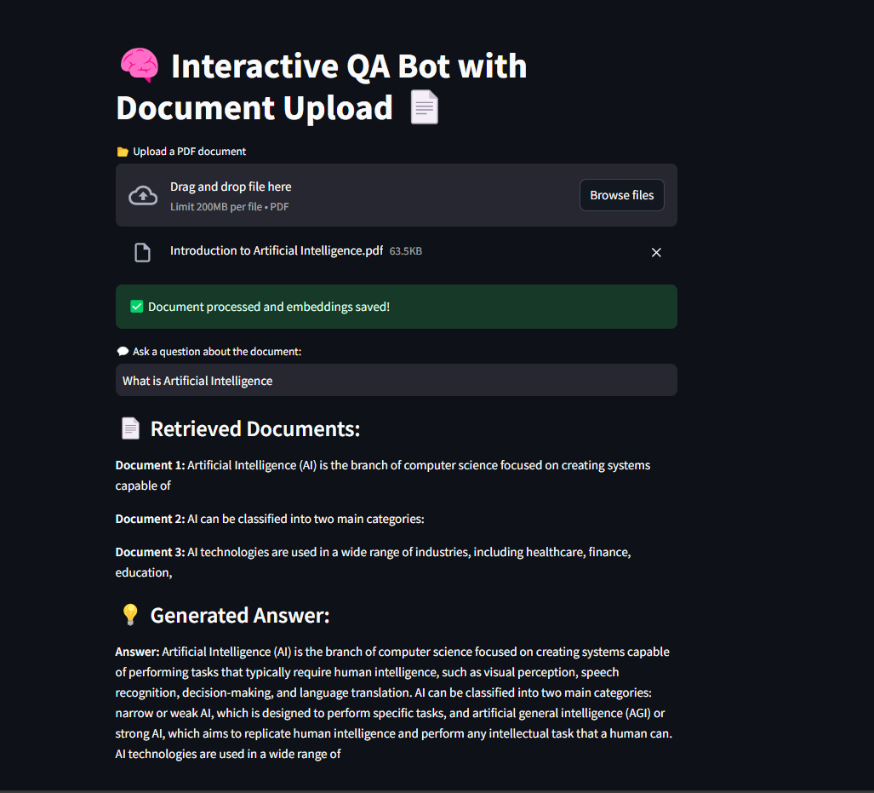

Example 2:

- Document: A PDF titled "Machine Learning Algorithms" is uploaded.

- User Question: "What is supervised learning "

- Output:

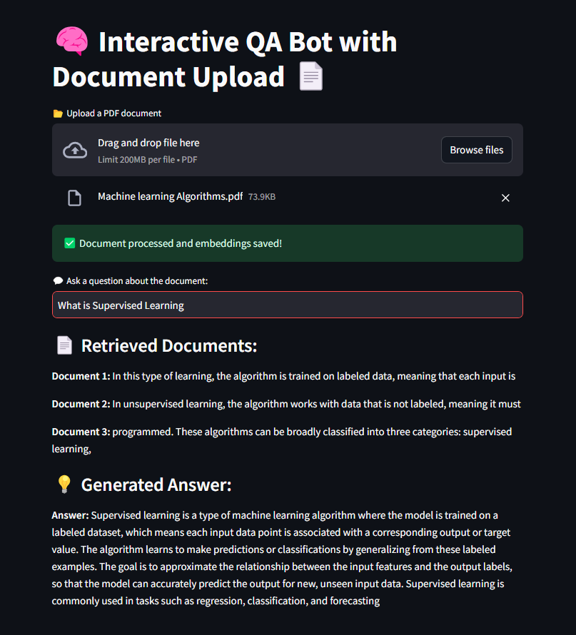

# **6. Deployment and Performance Considerations**

Guidelines for Deployment:

1. Containerization with Docker:

Dockerfile Creation: Create a Dockerfile to containerize the application. The Dockerfile should include steps to install dependencies, set up the environment, and run the Streamlit server.

```dockerfile

FROM python:3.9-slim

WORKDIR /app

COPY requirements.txt .

RUN pip install --no-cache-dir -r requirements.txt

COPY . .

EXPOSE 8501

CMD ["streamlit", "run", "Front_End.py"]

```

Build and Run:

Build the Docker image: `docker build -t qa-bot-app .`

Run the container: `docker run -p 8501:8501 qa-bot-app`

2. Handling Large Documents:

- Chunking: Implement chunking strategies to split large documents into smaller segments for processing and embedding.

- Memory Management: Monitor and manage memory usage to handle large document sizes without performance degradation.

3. Query Performance:

Index Optimization: Optimize Pinecone index configurations to handle high query loads efficiently.

Scalability: Ensure the application is scalable to accommodate multiple concurrent users and large volumes of queries.